**LEVEL 0**

**1)**

**2)**

1. After making a setup() operate, that initializes and sets the initial values, the loop() perform will exactly what its name suggests, and loops consecutively, permitting your

program to alter and respond. Use it to actively management the Arduino board

1. The for loop doesn't finish till you disconnect the board or reset it. as a result of it's endless .
2. While loops: can loop unendingly, and infinitely, till the expression within the parenthesis, () becomes false. one thing should modification the tested variable, or the whereas loop can never exit. this might be in your code, like an incremented variable, or an external condition, like testing a device.

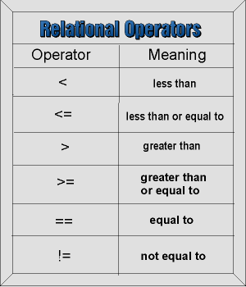**3)**

**Modify**

|  |  |
| --- | --- |
| Before: | (int i = BASE; i < BASE + NUM; i ++) |
| After: | (int i = BASE; i <= BASE + NUM; i ++) |

4)

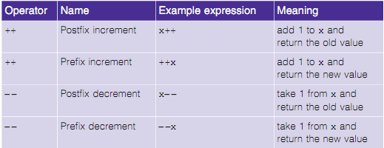

|  |  |
| --- | --- |
| Before | var x = 0; x++; // x is now 1 |
| After | var y = 0; y = y + 1; // y is now 1 |